Guest Post: The Gold Standard Debate Revisited

Submitted by Tyler Durden on 08/29/2012 14:32 -0400
Submitted by Pater Tenebrarum of Acting Man blog,

Why Trying to Prove a Point about Economics with 'Just Two Charts' is a Really Bad Idea

The Gold Standard Debate Revisited
The discussion over the GOP's gold standard proposals continues in spite of the fact that everybody surely knows the idea is not even taken seriously by its proponents – as we noted yesterday, there is every reason to believe it is mainly designed to angle for the votes of disaffected Ron Paul and Tea Party supporters, many of whom happen to believe in sound money. As we also pointed out, there has been a remarkable outpouring of opinion denouncing the gold standard. Unfortunately many people are misinformed about both economic history and economic theory and simply regurgitate the propaganda they have been exposed to all of their lives. Consider this our attempt to present countervailing evidence.

Demagoguery and Cherry-Picking Data
The 'Atlantic' felt it also had to weigh in on the debate, and has published an article that shows like few other examples we have examined over recent days how brainwashed the public is with regards to the issue and what utterly spurious arguments are often employed in the current wave of anti-gold propaganda. The piece is entitled “Why the Gold Standard Is the World's Worst Economic Idea, in 2 Charts”, and it proves not only what we assert above, it also shows clearly why empirical evidence cannot be used for deriving tenets of economic theory. Since we have first seen the article, its author has been forced to add a footnote, presumably because he received irate mail from readers complaining about his cherry-picking of data that seemingly fit his narrative, but he has not withdrawn his contentions.
The article uses the famous William Jennings Bryan 'Cross of Gold' speech as a polemic sound bite device apropos of precisely nothing. Bryan wanted the US treasury to continue supporting silver miners by artificially enforcing the fixed exchange rate of the bimetallic system. This has zero bearing on the question whether adopting a gold standard would be a good idea or not. But 'crucifying our economy on a cross of gold' sure sounds dramatic, and more importantly it sounds like 'gold is bad', which is why it was used.
The article compares the behavior of prices in the period 1919 to 1932 (which includes several periods of major monetary upheaval over which the Fed presided, namely the post WW I inflationary bust and the post 1929 deflationary bust, separated by the boom of the roaring 20's) – with the behavior of prices as measured today since 'QE' began in 2008.
The point the author is trying to 'prove' is that prices are more 'stable' under the fiat money system than they were under the gold standard, even though the modern-day Fed is evidently busy inflating the money supply all-out (a fact which he glosses over).
This is erroneous on a great many levels. First of all, it presupposes that 'stable prices' are a desirable goal. However, the so-called 'price stability policy' has proven to be quite misguided and dangerous (readers interested in why this is so should take a look at a detailed discussion of the problem in “The Errors and Dangers of the Price Stability Policy”). Moreover, if the author really wanted to make an empirical point about the relative stability of the currency's purchasing power under gold and under the centrally planned fiat money system, then why didn't he show us the chart below?

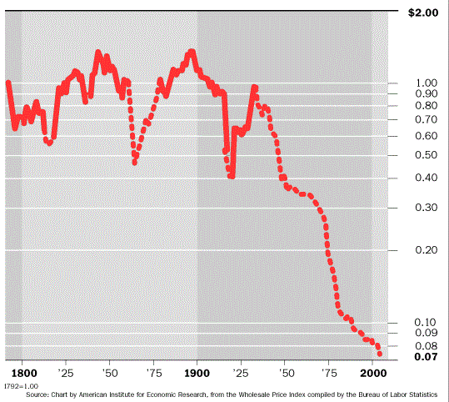#b7a971;" />
A log chart of the dollar's purchasing power from just before 1800 to about 2003. The dotted line shows the periods when gold convertibility was suspended – click chart for better resolution.

What is so remarkable about this chart is that the dollar's purchasing power was still the same on the eve of the founding of the Fed as it was at the beginning of the 19th century. Clearly the decision to abandon the gold standard has hastened the collapse of the dollar's value – at the point where the chart ends, 7 cents of the purchasing power of the gold-backed dollar of yore were left. Since then we have actually arrived at a paltry 4 cents.
So much for 'stable prices' under the fiat money regime – it has produced a 96% decline in the currency's purchasing power over the past century, in contrast with the perfect preservation of purchasing power during the century preceding the founding of the Fed.
We could actually leave it at that and simply state that the author of the Atlantic piece has obviously cherry-picked data in order to mislead his readers. However, there is more to it than that. Both ideological and economic questions are raised by the article.

The Consensus
We actually spilled some coffee due breaking out in laughter by the time we reached the second paragraph of the article. The author informs us:

“Economics is often a contentious subject, but economists agree about the gold standard — it is a barbarous relic that belongs in the dustbin of history. As University of Chicago professor Richard Thalerpoints out, exactly zero economists endorsed the idea in a recent poll.”

Obviously then, not a single Austrian school economist was included in the poll. We believe the poll result is what is colloquially known as a contrary indicator. The fact that establishment economists are unanimous in their rejection of the gold standard has not even necessarily to do with their actual views on monetary theory. In many cases it has likely more to do with the fact that most of them are bought and paid for by the State – deviating from the party line that a centrally planned fiat money is the be-all and end-all is widely regarded as a career killer.
If you want to know why, read this illuminating article that appeared at the Huffington Post: “Priceless: How The Federal Reserve Bought The Economics Profession”. This should be a true eye-opener for most people. So let's not be naïve and invoke the well-known logical fallacy of appeal to authority, in this case that of an alleged 'scientific consensus'. First of all this consensus does not exist, secondly many of the people who were asked the question would not dare to answer it differently. It is exactly as Hans-Hermann Hoppe once said:

“[...] intellectuals are now typically public employees, even if they work for nominally private institutions or foundations. Almost completely protected from the vagaries of consumer demand ("tenured"), their number has dramatically increased and their compensation is on average far above their genuine market value. At the same time the quality of their intellectual output has constantly fallen.

What you will discover is mostly irrelevance and incomprehensibility. Worse, insofar as today's intellectual output is at all relevant and comprehensible, it is viciously statist. There are exceptions, but if practically all intellectuals are employed in the multiple branches of the State, then it should hardly come as a surprise that most of their ever-more voluminous output will, either by commission or omission, be statist propaganda.”

(emphasis added)

Economic History
Then the Atlantic author goes on to present the stock argument against gold that is forwarded by all and sundry when the gold standard is discussed:

“What makes it such an idea non grata? It prevents the central bank from fighting recessions by outsourcing monetary policy decisions to how much gold we have — which, in turn, depends on our trade balance and on how much of the shiny rock we can dig up. When we peg the dollar to gold we have to raise interest rates when gold is scarce, regardless of the state of the economy. This policy inflexibility was the major cause of the Great Depression, as governments were forced to tighten policy at the worst possible moment. It's no coincidence that the sooner a country abandoned the gold standard, the sooner it began recovering.

Why would anyone want to go back to the bad old days? The gold standard limited central banks from printing money when economies needed central banks to print money, and limited governments from running deficits when economies needed governments to run deficits. ”

Again, this argument glosses over the fact the biggest economic busts in history were the end result of booms the Federal Reserve aided and abetted. To be sure, when looking at the purchasing power of the gold-backed dollar during the 19th century, although it turned out to be extremely stable in the long run, one can see that there were considerable fluctuations in the shorter term. Apart from the major fluctuation actuated by the abandonment of gold convertibility during the civil war, all the other ups and downs were the result of the booms and busts engendered by fractionally reserved banks engaging in credit expansion, quite often hand in hand with some form of government intervention.
This is not the space to recount the entire monetary and banking history of the United States, but it must be made clear that even under a gold standard, credit expansions by means of fractional reserve banking can and do take place and create the familiar phenomena of the boom-bust cycle.
The business cycles of the 19th century were fairly harmless compared to today's. The fiduciary media created during credit expansions were usually destroyed by the subsequent deflationary busts, and so the purchasing power of the currency was as a rule always restored to its pre-boom level, as the extant money supply returned to the amount effectively backed by specie.
It is quite different today, when there is a lender of last resort with the ability to create money ex nihilo in unlimited amounts. Banks will take far greater risks, become far more leveraged and this will result in far bigger – both in duration and amplitude - boom-bust cycles. Moreover, a steady erosion of the currency's purchasing power is dead certain due to the explicitly inflationary policy of the central bank.
The inflexibility of the monetary system under a gold standard which the Atlantic author bemoans (“we have to raise interest rates when gold is scarce, the central bank will be prevented form printing money”, etc.) is precisely what makes the gold standard a superior system. This inflexibility is what stands in the way of wealth confiscation by the State and the banking cartel. It also stands in the way of the perpetuation of capital malinvestment, which the 'flexible' centrally planned currency practically guarantees.
As to the 'recovery' observed upon abandonment of the gold standard in the 1930's, it quickly turned out to be a fata morgana. As soon as the central bank was forced to tighten credit only a little bit to avoid run-away inflation, the recovery immediately collapsed again. It was an inflationary illusion and therefore unsustainable. There is a reason why the entire period in question is today known as the 'Great Depression' and not as 'the two recessions and the boom of the 1930's'.

Money Printing and Wealth Creation
All the assertions about the advantages of money printing and interest rate manipulation rest on the fallacy that printing money can actually create wealth and that manipulating the market interest rate below the level dictated by the intertemporal preferences of economic actors can actually be beneficial.
The exact opposite is true: money is the only good in the economy an increase in the supply of which confers no benefit to society whatsoever. Why anyone would think that price fixing – which is what the interest rate manipulation of the central bank amounts to – is a good policy is utterly incomprehensible. Either price fixing as such is economically beneficial, or it isn't.
Regardless of which school of thought they belong to, economists by and large do agree that price controls are a bad idea, as this is something both economic theory and historical experience show unequivocally.
Somehow they make an exception though when it comes to money: in the realm of money, price fixing and central planning are deemed to be the just fine. The contradiction inherent in holding these diametrically opposed beliefs concurrently is never discussed – obviously, raising this question would force many economists to confront something they prefer to gloss over so as not to suffer career setbacks (see above).
Lastly, it is always implicitly assumed that somehow, the labor market will move from a state of 'equilibrium', this is to say a state when there is no involuntary unemployment, to a state of 'disequilibrium' by mysterious forces that are deemed to be an inherent feature of the market economy. What is usually neglected in these deliberations is to provide an explanation as to how the previous state of equilibrium came into being in the first place. If it is true that recessions and unemployment are a 'natural' feature of the market economy that require government intervention, then why are there periods when the economy is apparently providing full employment (excluding the catallactic unemployment residual) all by itself? How could these happy states of affairs ever come about? The interventionists are silent on this point.

A Question of Methodology
The cherry-picked data series used in the Atlantic demonstrate a problem of methodology as well. As noted above, the 1919-1932 period was one of great economic and monetary upheaval. In 1914-1919, during which time the gold standard was actually suspended in order to finance WW I, there was an enormous explosion in prices, which is a recurring phenomenon when wars are financed by means of inflation.
In the severe recession of 1920-1921, which today no-one remembers because it was over so quickly, the at the time still quite conservative Fed decided to adopt a very tight monetary policy in order to bring prices down again. Concurrently the Harding administration refused to engage in deficit spending and economic intervention. It was the very last time in history that a US administration adopted a 'laissez-faire' stance during an economic contraction. Given how quickly the recession was over, this approach evidently worked quite well.
Curiously though, the author of the Atlantic article never apprises his readers of this fact, in spite of using the period in question to attempt to prove the exact opposite, namely that both money printing and deficit spending are allegedly desirable and necessary during recessions.
It is also not once mentioned that the gold convertibility of the dollar did not keep the banking system from expanding the money supply. According to calculations by Murray Rothbard in 'America's Great Depression', the true US money supply expanded by roughly 66% during the boom of the roaring 20's. The Federal Reserve's much too loose monetary policy was the main reason for the enormous money supply and credit expansion during this time. Not surprisingly, a major bust ensued after the Fed belatedly tightened credit in 1929.
What we want to point out here is this: leaving aside the fact that the author compares apples and oranges to begin with, as the calculation of CPI has been altered beyond recognition in modern times, one cannot just arbitrarily pick two data series and assert that they prove a point of economic theory.
The historical data of the market are always highly complex, with countless dynamic factors influencing every given slice of economic history – therefore, economic history is always unique. One cannot engage in repeatable experiments to test 'hypotheses' of economic theory.
Rather, the only thing one can do is to interpret economic history with the help of sound economic theory – in the social sciences, theory is antecedent to history. It may be that one's theory is flawed, but economic history can not be used to prove or disprove a point of theory. The only way of disproving tenets of economic theory is by means of causal-rational deductive reasoning.
As Ludwig von Mises notes in Human Action, ch. XXIII,1.:

“When an institutionalist ascribes a definite event to a definite cause, e.g., mass unemployment to the alleged deficiencies of the capitalist mode of production, he resorts to an economic theorem. In objecting to the closer examination of the theorem tacitly implied in his conclusions, he merely wants to avoid the exposure of the fallacies of his argument.

There is no such thing as a mere recording of unadulterated facts apart from any reference to theories. As soon as two events are recorded together or integrated into a class of events, a theory is operative. The question whether there is any connection between them can only be answered by a theory, i.e., in the case of human action by praxeology. It is vain to search for coefficients of correlation if one does not start from a theoretical insight acquired beforehand.

The coefficient may have a high numerical value without indicating any significant and relevant connection between the two groups.”

(emphasis added)

Economic Forecasting
Economic theory can explain why the recent period of extremely high inflation (note that we use the term inflation here in its original meaning, namely denoting an expansion of the money supply) has not yet led to a massive increase in final goods prices. Any assertions and forecasts we can make in the context of the fact that the Fed has expanded the money supply by over 80% in the past four years are however constrained by the laws of praxeology.
Or to put this in different words: it is our a priori knowledge of economic laws as deduced from the axiom of human action that allows us to make qualitative assessments of the economy based on the market data. Prediction is constrained in this manner as well, but in another sense is a different matter altogether: we cannot know today what the future states of knowledge of economic actors will be. Therefore, economic forecasts will always be subject to considerable uncertainty.
Let us consider the inflation of the money supply in light of the kernel of truth contained in the quantity theory of money. Since we don't know with certainty whether the money supply will continue to be increased in the future and we also don't know with certainty whether the demand for money will decrease, increase, or remain the same, we can make no apodictic forecasts regarding future developments in the purchasing power of money.
What we can say with certainty is that the increase in the money supply hitherto has altered relative prices in the economy and that it has enabled exchanges of 'nothing' (money from thin air) for 'something' (real resources that could be bid for with this money) and that this has led to a redistribution of wealth from later to earlier receivers of the newly created money. We know that the economy's entire price structure has been altered from the state it would have attained absent the inflation.
We can also state with certainty what would happen in the future if we apply a number of ceteris paribus assumptions. If for instance the quantity of money in the economy continues to be increased (a good bet), but the demand for money remains constant or declines and no goods-induced changes in purchasing power occur, then final goods prices will certainly rise.
Our forecasts must always be a mixture of the constraints imposed by the laws of praxeology and what Mises called 'understanding'. Obviously, some will be better at forecasting than others; economists employing causal-logical reasoning will on average always have a leg up on the competition. These are mainly the economists that were not asked for their opinion in the poll cited by the author of the Atlantic article. :)

Ludwig von Mises on the Gold Standard
We have already pointed out that to us, the most important thing is that money be returned to the free market instead of being administered by the State. It is a good bet that the market would choose gold (and perhaps also silver) as its money, but this is not the decisive point.
However, it is quite clear that a gold standard would be vastly preferable to the legal tender credit money we use at present.
We leave you with a few pertinent quotes on the gold standard by Ludwig von Mises, which enumerate both its undeniable advantages as well as the motives of its enemies:

“The return to gold does not depend on the fulfillment of some material condition. It is an ideological problem. It presupposes only one thing: the abandonment of the illusion that increasing the quantity of money creates prosperity.” (in 'Economic Freedom and Interventionism')

“The gold standard did not collapse. Governments abolished it in order to pave the way for inflation. The whole grim apparatus of oppression and coercion, policemen, customs guards, penal courts, prisons, in some countries even executioners, had to be put into action in order to destroy the gold standard.” (in: 'The Theory of Money and Credit')

"The excellence of the gold standard is to be seen in the fact that it renders the determination of the monetary units purchasing power independent of the policies of governments and political parties.” (ibid.)

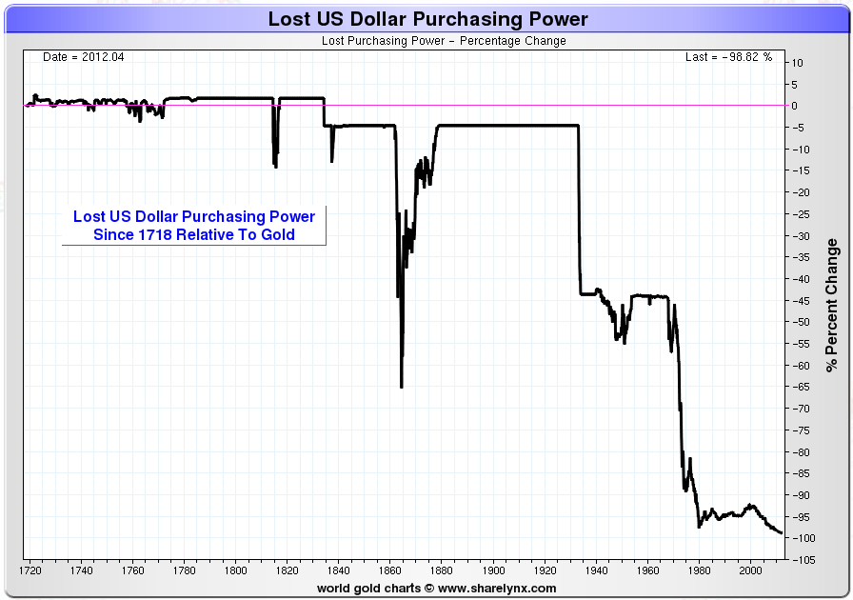#b7a971;" />
The percentage decline of the US dollar against gold since 1718, via Sharelynx - click chart for better resolution.

Charts by: American Institute for Economic Research, Sharelynx

- 9823 reads

